**SAE INDIA COLLEGIATE CLUB NIT RAIPUR**

SAE COLLEGIATE CLUB , NIT RAIPUR is a professional club of mechanical engineering department aimed towards enriching the practical knowledge of students in development, design, manufacture and utilization of mobile vehicles.

We are a part of the global organization whose clubs are spread all over the country.

**HISTORY**

The club was formed in the year 2014 under the forthright leadership of Dr. S Sanyal – Professor and Dean(R& C) Mechanical engineering department with a total of 119 members. The progress of the club has jumped by leaps and bounds from that time with its activities covering events and activities from SAE , ASME , ISNEE and several research projects.

The club is backed by the cooperation of the faculties of the department.

|  |  |  |
| --- | --- | --- |
| Dean (R&C) | Dr. S Sanyal(Professor) |  |
| Senior faculty advisor | Dr. S K Mukti (Asst. Professor) | Image not available |
| Faculty advisor | Mr S Vaidya (Professor) | Image not available |

**ACTIVITIES**

To foster the nuts and bolts knowledge of the students the members participate in several engineering competitions of SAE INDIA.

**BAJA:-**

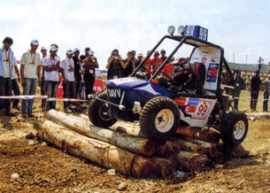Baja SAE is an [intercollegiate](https://en.wikipedia.org/wiki/College_athletics) design competition run by the [Society of Automotive Engineers](https://en.wikipedia.org/wiki/Society_of_Automotive_Engineers) (SAE). Teams of students from [universities](https://en.wikipedia.org/wiki/University) all over the country design and build small [off-road](https://en.wikipedia.org/wiki/Off-road) [cars](https://en.wikipedia.org/wiki/Automobile). The goal in Baja SAE racing is to design, build and race off-road vehicles that can withstand the harshest elements of rough terrain. The vehicles used in Baja SAE racing are often similar in appearance to dune buggies.

The evaluation process for the BAJA SAEINDIA is a twofold process and students have to clear the Virtual Baja preliminary round before they start manufacturing their buggy’s for the main events.

The teams are judged on six main parameters in the Virtual BAJA event which are – their knowledge of the rule book, the design of the vehicle, the project plan, the design methodology and the design evaluation plain. A total of 400 points are available for each team’s design and the top 120 teams are selected to compete in the main event.

**CLUB PARTICIPATION**

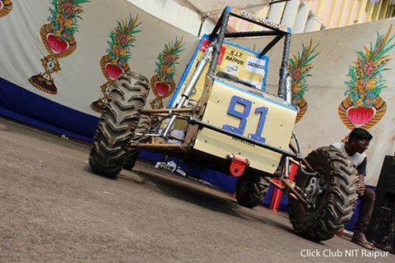Team Dynamic participated in Baja SAE 2016 and was ranked 126 out of 395 teams participating in its very first event. The team was ranked 65th in the virtual round.

The team successfully qualified technical inspection and turning radius test .

Team Dynamic is ready again filled with zealous members to participate in Baja SAE 2107.

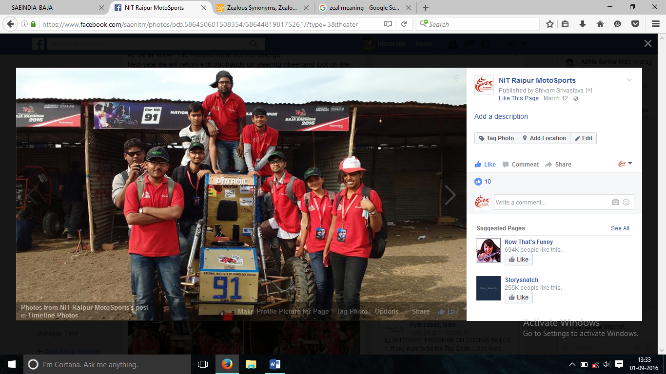The team has already qualified Baja Virtual event and the fabrication of the vehicle is on the way.

TEAM DYNAMIC’S BUGGY BUMBLEBEE PARTICIPATED IN BAJA 2016

**EFFICYCLE**

|  |
| --- |
| EFFI-CYCLE” derived from Efficient-Cycle promote the objective of providing oppurtunity to the students to conceive, design and fabricate a three wheel configuration vehicle powered by human-electric hybrid power and capable of seating two passengers catering to the day to day mobility needs. The vehicle must be aerodynamic, engineered for performance & safety and ergonomically designed. The objective is to promote innovation and generate consciousness amongst the young engineers towards environment friendly mobility solution.  **CLUB PARTICIPATION**  https://scontent.fbom1-1.fna.fbcdn.net/v/t1.0-9/12115967_535573586596056_4131738746209377240_n.jpg?oh=c89d290765797662ed2b0db95d2944d0&oe=584D0596  Team SAMARTHYA participated in SAENIS Efficycle 2015 held in LPU from 15th -18th Oct 2015 was ranked 43rd in their debut performance. |
|  |  |
| **FUTURE PLANS**  **SUPRA SAE INDIA**  The concept behind Formula SAE is that a fictional manufacturing company has contracted a student design team to develop a small [Formula-style](https://en.wikipedia.org/wiki/Formula_One) [race car](https://en.wikipedia.org/wiki/Race_car). The prototype race car is to be evaluated for its potential as a production item. The target marketing group for the race car is the non-professional weekend [autocross](https://en.wikipedia.org/wiki/Autocross) racer. Each team designs, builds and tests a prototype based on a series of rules, whose purpose is both ensuring on-track safety (the cars are driven by the students themselves) and promoting clever problem solving. | **SAE NIS EFFI-CYCLE is an Intercollegiate design competition for the undergraduate and graduate engineering students where team of 6-10 students have to design and fabricate an energy efficient Hybrid human powered three wheeled electric vhicle.** |
| The team from SAE CLUB,NIT RAIPUR plans to participate in FSAE 2017. |  |
|  | **This event provides opportunity for the engineering students by setting up the trend of using eco- friendly vehicle in India and come up with some innovative designs.** |
|  |  |
|  | **The vehicle should be capable to be driven simultaneously as well as alternatively by two drivers and also run simultaneously or alternatively on an electric drive.** |